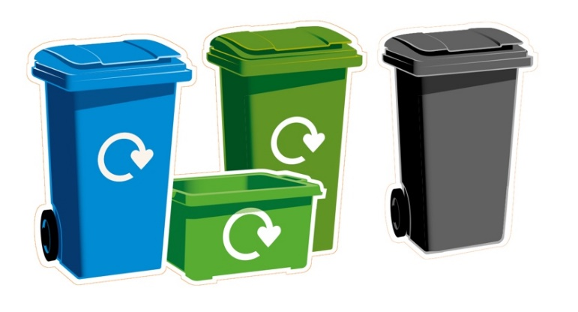

Dear Resident

Important information about your waste and recycling service

Your collection day is a ………………………….

On collection day please
- Put your bin out by 7am
- Ensure the bin lid is fully closed
- Do not leave loose waste or bags next to your bin, it won’t be taken
- Take your bins off the street once they have been emptied
scan for link
To check your collection days, you can access a digital version of the calendar by asking Alexa or at www.doncaster.gov.uk/recycling.
For further information or to order replacement containers, visit www.doncaster.gov.uk/recycling

Waste Collection

We cannot collect any batteries in any bin as they cause ﬁres

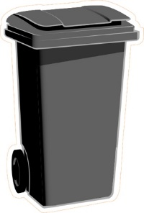
Please put these items in your black bin

Plastic film and Pet Tetra
carrier bags waste paks

Nappies Ash Broken Cardboard or
No hot ashes crockery paper food
residue

Pyrex or Food Polystyrene Plastic pots,
window glass tubs and trays

Recycling Collection

We cannot collect any batteries in any bin as they cause ﬁres

Recycling instructions on packaging may not apply, so please use
our guidelines below

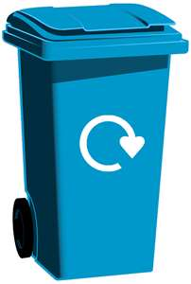
Please put these items in your blue recycling bin
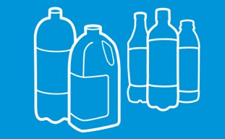
Plastic bottles only
Rinse, squash, remove lids and put in
your blue bin.
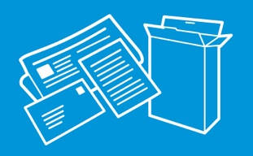
Paper & cardboard
Remove plastic packaging and polystyrene.

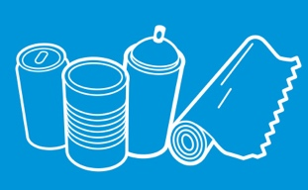
Aerosols, cans, tins & foil

Plastic recycling
Plastic bottles are the only type of plastic we can accept in your blue bin.
Plastic pots, tubs, trays, ﬁlm and bags MUST go in your black bin.

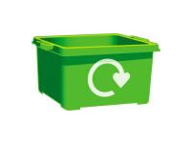
Please put these items in your green recycling box
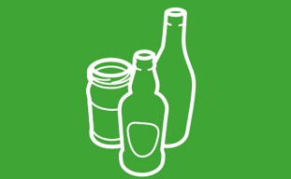
Glass bottles & jars
Rinse, no broken glass, no lids.

Waste small electrical items can be placed in a plastic bag alongside your recycling (do not put in your bin)

Household Waste Recycling Centres
scan for link �
You can dispose of extra household waste and recycling at our Household Waste Recycling Centres. Find out the locations and opening times at www.doncaster.gov.uk/hwrc

We thank you for your assistance to help make your neighbourhood and surroundings a cleaner, greener place to live.

Yours sincerely
The Waste & Recycling Team
Doncaster Waste Transfer Station, Sandall Stones Road, Kirk Sandall Industrial Estate, Doncaster DN3 1QR

Green Garden Waste Collection

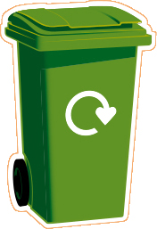
Please continue to use your green bin for garden waste

Your green bin should only contain the following

- Grass cuttings
- Plants and weeds
- Prunings and twigs
- Leaves
- Hedge clippings
- Old or dead houseplants

Common items that should NOT go in your recycling or garden waste containers

- Refuse / black sacks
- Food waste
- Tissues and kitchen roll
- Soil
- Plastics we don’t recycle (pots, tubs, trays, ﬁlm and bags)
- Batteries
- Rubble / stones
- TetraPaks and food cartons

